Robbie Robot Shop Usage Manual

Part creation

- In order to create a part you will need to navigate to the menu bar above the main menu and select the Add Parts option.

- This will allow you to choose which type of part you would like to create from a drop down menu.
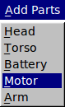

- Your selection will introduce a new window to the screen. You may select cancel in the bottom right corner at anytime in order to return to the main menu without introducing any changes to the data. Simply fill in the corresponding fields with the necessary data to create your part and press enter.
  - By pressing data a new Part object will be created and the data will be saved to the “data.txt” file in the primary directory.

Model Creation

- In order to define a model you will need at least one instance of each type of part to have been defined. You can navigate to the Models tab in the menu bar and you will be able to choose to either define a new model or list current models.
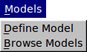

- Your selection of “Define Model” will introduce a new window to the screen. You may select cancel in the bottom right corner at anytime in order to return to the main menu without introducing any changes to the data. You may enter the corresponding data into the fields in order to define a new model. For the fields named Torso Number, Head Number, Motor, Number, Battery Number, Arm Number, you must input the INDEX number of the part you wish to use for the model. This can be found by click the button to the left of each of these fields to list all of the existing parts for each part types. The index number will be in parenthesis.

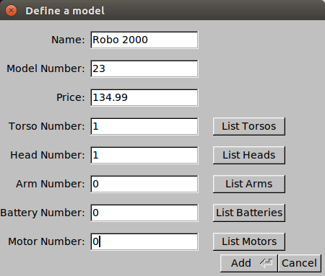

  - By pressing data a new Part object will be created and the data will be saved to the “data.txt” file in the primary directory.

